Cost-based optimizer

Lab 1: The EXPLAIN command
Estimated completion time
- 20 minutes

Learning objectives
- In this lesson, you will examine query plans using the SQL command EXPLAIN. You will use the EXPLAIN command with two different catalogs, hive and MySQL.

Activities
- Understanding pushdown
- Using EXPLAIN on a relational database
- Run the query
- Run the EXPLAIN command for the previous query
- Review EXPLAIN plan fragments and operators
- Review plan Fragment 1
- Review plan Fragment 0
- Running EXPLAIN on a data lake
- Run EXPLAIN on the query for the first time
- Review plan Fragment 1

Step 1 - Understanding pushdown
One common term that you will hear when learning about query plans is pushdown. Pushdown happens when Starburst pushes a portion of the query processing down to the underlying data source, allowing the data source to complete the processing.

An example of this could be a WHERE clause that will filter out some of the rows. It is more efficient to ask the underlying data source to do this, so fewer rows are returned to Starburst. Depending on the connector type, there may not be an underlying process engine. In that case, Starburst has to do the work.

As you work through this lesson, pay attention to any pushdown that is occurring.

Step 2 - Using EXPLAIN on a relational database

Log into your Starburst Galaxy account. Expand Query and click Query editor. Set the cluster to query-plan-labs. Set the catalog to mysql_query_plan. Set the schema to query_plan_without_stats.

Step 3 - Run the query
This query returns a list, grouped by market segment, of the aggregated count of customers with a balance over $1,000. As you will see in the results, this query returns five total rows, showing that you have five market segments. This is an important thing to remember for later.

Run the following query:

SELECT c.mktsegment, COUNT(*)
FROM customer c
WHERE c.acctbal > 1000
GROUP BY c.mktsegment;

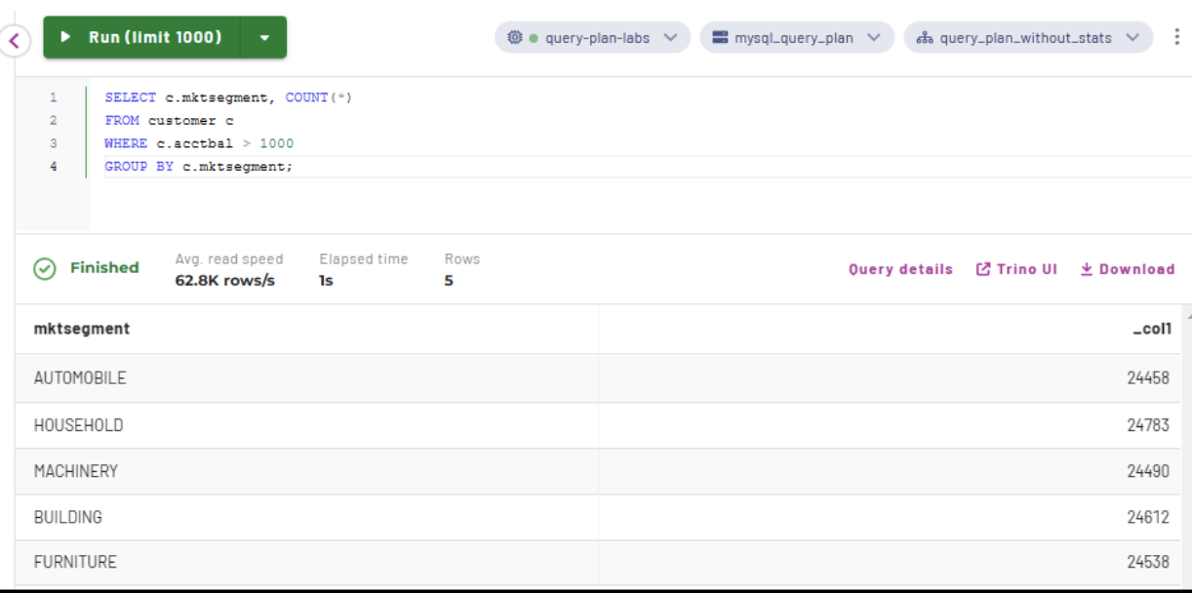

Step 4 - Run the EXPLAIN command for the previous query
Notice that the SQL is almost identical to the previous step; you are just adding EXPLAIN to the beginning.

EXPLAIN
SELECT c.mktsegment, COUNT(*)
FROM customer c
WHERE c.acctbal > 1000
GROUP BY c.mktsegment;

Step 5 - Review EXPLAIN plan fragments and operators
Please note that your exact results may differ from the images shown, depending on the number of nodes you are using.

Begin your analysis with the highest-numbered fragment at the bottom. Always read from the bottom up to review fragments. You should also read from the bottom up within each fragment.

The bottom fragment will always be the SOURCE fragment. Fragments that are not SOURCE fragments will have a RemoteSource [X] Operator, where X is the number of the lower fragment that sent (exchanged) data to the current fragment.

Fragment 0 [HASH]
Output layout: [mktsegment, count]
Output partitioning: SINGLE []
Output[columnNames = [mktsegment, _col1]]
│ Layout: [mktsegment:varchar(255), count:bigint]
│ Estimates: {rows: ? (?), cpu: 0, memory: 0B, network: 0B}
│ _col1 := count
└─ Project[]
│ Layout: [mktsegment:varchar(255), count:bigint]
│ Estimates: {rows: ? (?), cpu: ?, memory: 0B, network: 0B}
└─ Aggregate[type = FINAL, keys = [mktsegment], hash = [$hashvalue]]
│ Layout: [mktsegment:varchar(255), $hashvalue:bigint, \
count:bigint]
│ Estimates: {rows: ? (?), cpu: ?, memory: ?, network: 0B}
│ count := count("count_0")
└─ LocalExchange[partitioning = HASH, hashColumn = [$hashvalue], \
arguments = ["mktsegment"]]
│ Layout: [mktsegment:varchar(255), count_0:bigint, \
$hashvalue:bigint]
│ Estimates: {rows: ? (?), cpu: ?, memory: 0B, network: 0B}
└─ RemoteSource[sourceFragmentIds = [1]]
Layout: [mktsegment:varchar(255), count_0:bigint, \
$hashvalue_1:bigint]
Fragment 1 [SOURCE]
Output layout: [mktsegment, count_0, $hashvalue_2]
Output partitioning: HASH [mktsegment][$hashvalue_2]
Aggregate[type = PARTIAL, keys = [mktsegment], hash = [$hashvalue_2]]
│ Layout: [mktsegment:varchar(255), $hashvalue_2:bigint, count_0:bigint]
│ count_0 := count(*)
└─ ScanProject[table = mysql_query_plan:query_plan_without_stats. \
customer query_plan_without_stats.customer constraint on \
[acctbal] columns=[mktsegment:varchar(255):TINYTEXT]]
Layout: [mktsegment:varchar(255), $hashvalue_2:bigint]
Estimates: {rows: ? (?), cpu: ?, memory: 0B, network: 0B}/ \
{rows: ? (?), cpu: ?, memory: 0B, network: 0B}
$hashvalue_2 := combine_hash(bigint '0', COALESCE( \
"$operator$hash_code"("mktsegment"), 0))
mktsegment := mktsegment:varchar(255):TINYTEXT
SOURCE fragment
The bottom fragment will always be the SOURCE fragment. It is also the highest-numbered fragment. Query plans should be read from the bottom up.

Remote source operator
Fragments that are not SOURCE fragments will have a RemoteSource [X] operator, where X is the number of the lower fragment exchanged (sent) data to the current fragment. So, in this case, Fragment 1 sent data to Fragment 0.

Step 6 - Review plan Fragment 1
Review the labeled graphic of Fragment 1 below. Click on each plus sign to learn more about the corresponding section of the fragment.

Note: Don't forget to read from the bottom up.

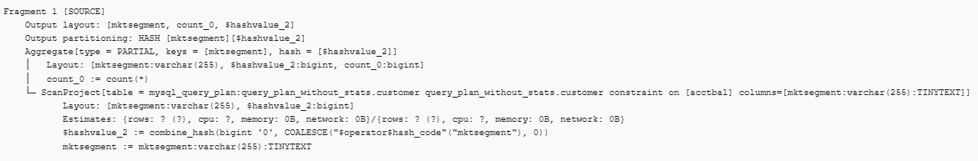

Click here to explore the query plan fragment.

Step 7 - Review plan Fragment 0
Review the labeled graphic of Fragment 0 below. Click on each plus sign to learn more about the corresponding section of the fragment.

Note: Don't forget to read from the bottom up.
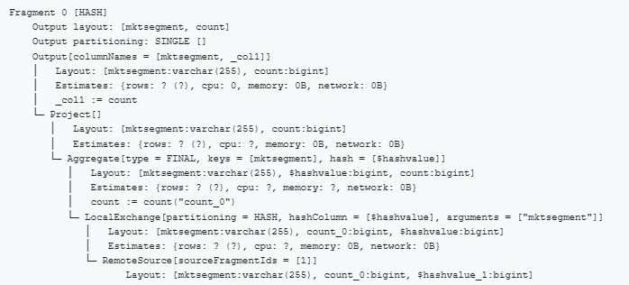

Click here to explore the query plan fragment.

Step 8 - Running EXPLAIN on a data lake
In this section, you’ll run EXPLAIN on the same query that you ran in the last section. This time, however, you will be querying a data lake rather than a relational database. The explanations provided will focus on the differences between hive and what you saw with MySQL.

Open another browser tab and log in to your Starburst Galaxy account. Expand Query and click Query editor.

Now set the cluster to query-plan-labs. Set the catalog to lakehouse_query_plan. Set the schema to query_plan_without_stats.

Step 9 - Run EXPLAIN on the query for the first time
Use EXPLAIN on the query using the code below.

EXPLAIN
SELECT c.mktsegment, COUNT(*)
FROM customer c
WHERE c.acctbal > 1000
GROUP BY c.mktsegment;

Step 10 - Review plan Fragment 1
Fragment 0 is identical to what you saw above with the relational database. Fragment 1 has a slightly different operator, as you’ll see now.

Review the labeled graphic of Fragment 1 below. Click on each plus sign to learn more about the corresponding section of the fragment.

Note: Don't forget to read from the bottom up.

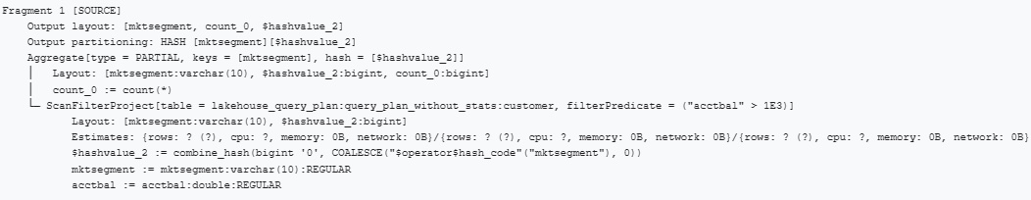

Click here to explore the query plan fragment.

The EXPLAIN command is a convenient tool used to view a logical query plan without actually executing the query. Query plans are composed of numbered fragments. When reviewing a query plan, you must always start from the bottom, or SOURCE, fragment.

Knowing how to interpret this output is critical to performance tuning. In the next lesson, you will get some more practice with query plans, this time using the EXPLAIN ANALYZE command.

END OF LAB EXERCISE

